**link for nfs code**: <https://github.com/NicoHood/HoodLoader2>

# HoodLoader2.0.5

[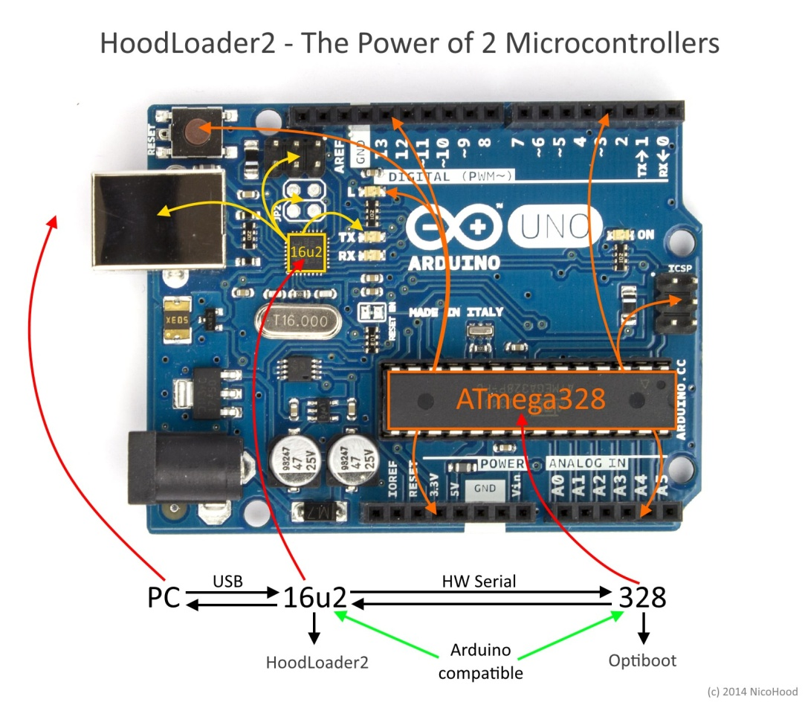](https://github.com/NicoHood/HoodLoader2/blob/master/header.jpg)

**HoodLoader2 is a CDC BootLoader with self reprogramming and Fast USB-Serial function.**

* An Arduino Uno/Mega board has two Microcontroller of which one(16u2) is normally used for USB-Serial translation.
* But we can also use it as standalone AVR Microcontroller with (or without) USB functions as well.
* HoodLoader2 gives you the option to **reprogram the 16u2** of a normal Arduino Uno/Mega R3 with **custom sketches**.
* This means you can use the 16u2 as a normal USB AVR like a Leonardo.
* You have a full compatible USB-HID core, CDC Serial and you can also use the 7 i/o pins of the 16u2.
* The extended HID devices of the [HID Project](https://github.com/NicoHood/HID) also apply for the HoodLoader2.
* The 16u2 is somehow limited in its functions but still a great addition if you know how to use it.
* It also compatible with [FastLED](https://github.com/FastLED/FastLED) and [IRLremote](https://github.com/NicoHood/IRLremote)(with PCINT) for example.
* The great thing about this is that you actually have **two fully Arduino compatible Microcontrollers in one Arduino Uno/Mega board** – the board most of you already own.
* Your IO MCU (328/2560) is **still reprogrammable** if you enter bootloader mode. All you need for this is a normal Arduino Uno/Mega R3 and some cables to install the new HoodLoader2.
* With version 2.0.5 you can now use HoodLoader2 also on a 32u4 which gives you even more power.
* So what we are doing here is to program the USB MCU separately with **custom code**. Both of them are running **independent** from each other. If you are uploading USB stuff to the USB MCU you cannot blink the LED on pin 13 of the I/O MCU within the same sketch. You'd have to upload and compile two different programs for two different MCUs and [switch to bootloader mode again](https://github.com/NicoHood/HoodLoader2/wiki/How-to-use-reset).